Sewing pattern for an AT-AT Walker!
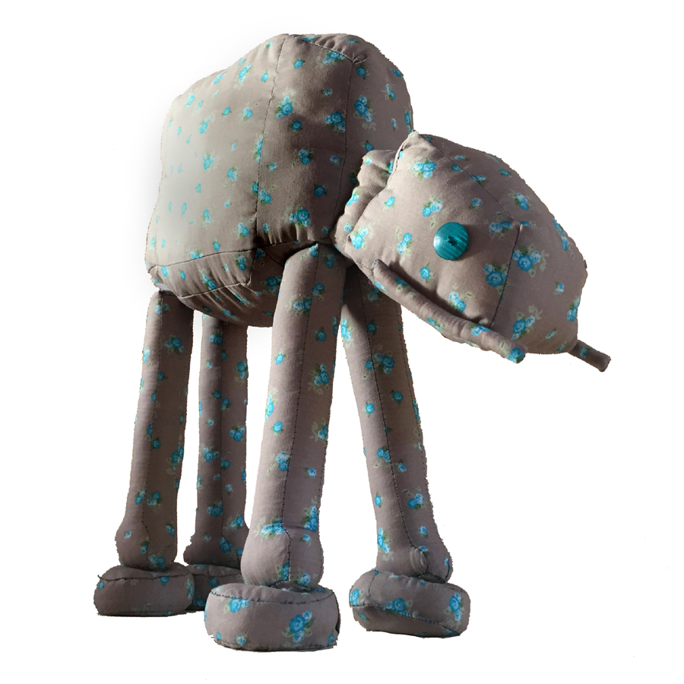
In this document you will find how to sew an awesome AT-AT Walker. There are nine pages filled with shapes to cut out (most of them once, some two or four times and some even eight times) and there are some pages with photo’s that might help with the proces. In each shape is written what part of the Walker it is and how often you’ll need that particular shape.

You will need:
- 1.40 x 2.00 metres of fabric (this is more than enough!)
- 2 nice big buttons for the eyes
- Optional: velcro tape

Cutting out the shapes:
- Print this document on A4-paper, the shapes will then have the right size.
- Cut out the shapes with half a centimetre on eacht side: 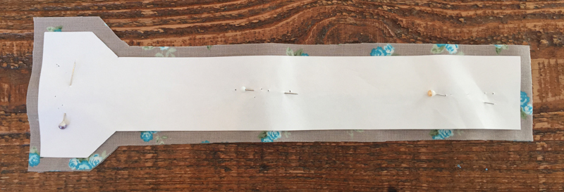
- Please note: some shapes must be cut out twice, of which one ‘reversed’.
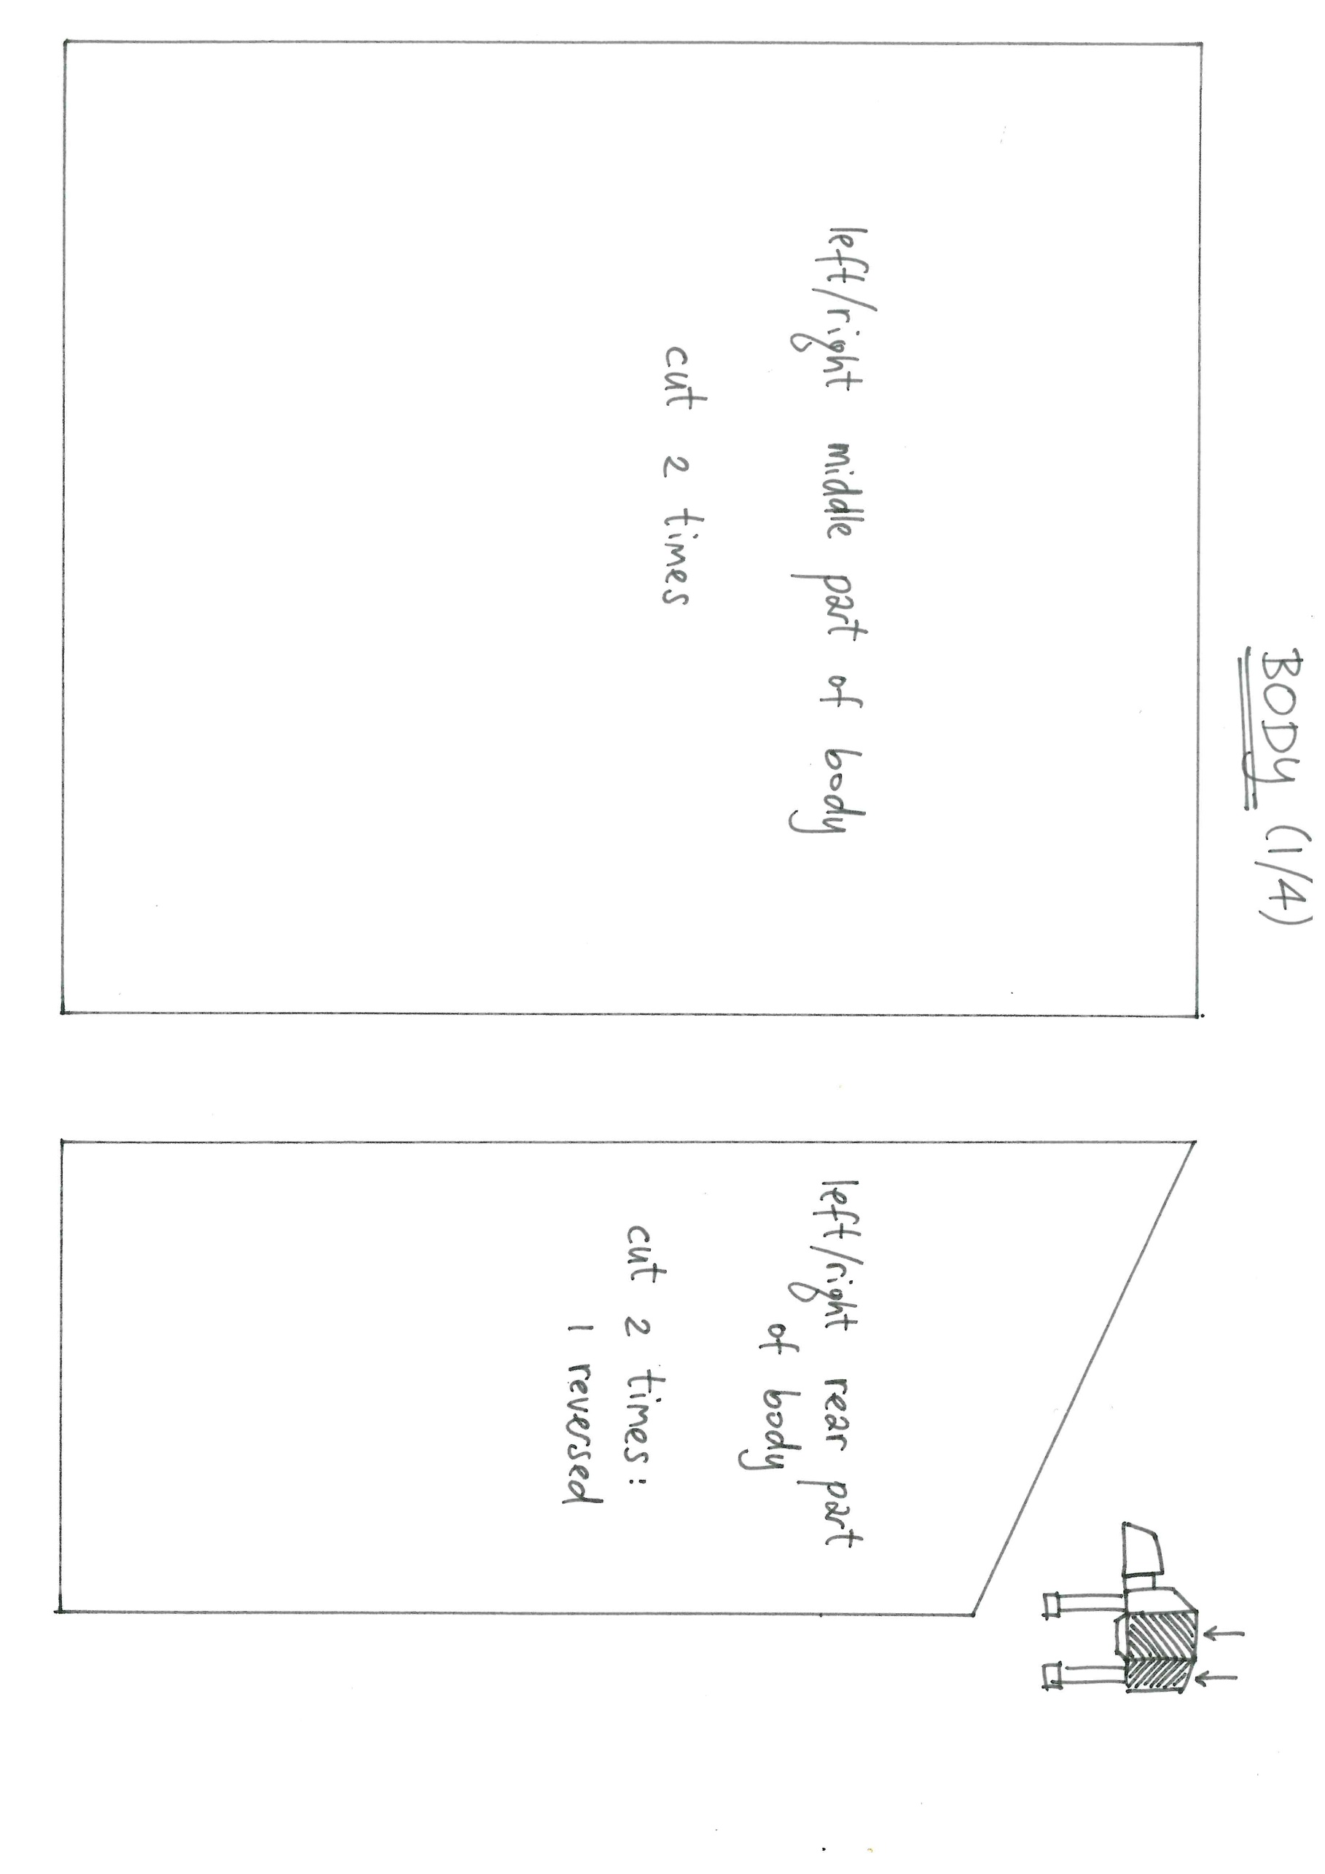
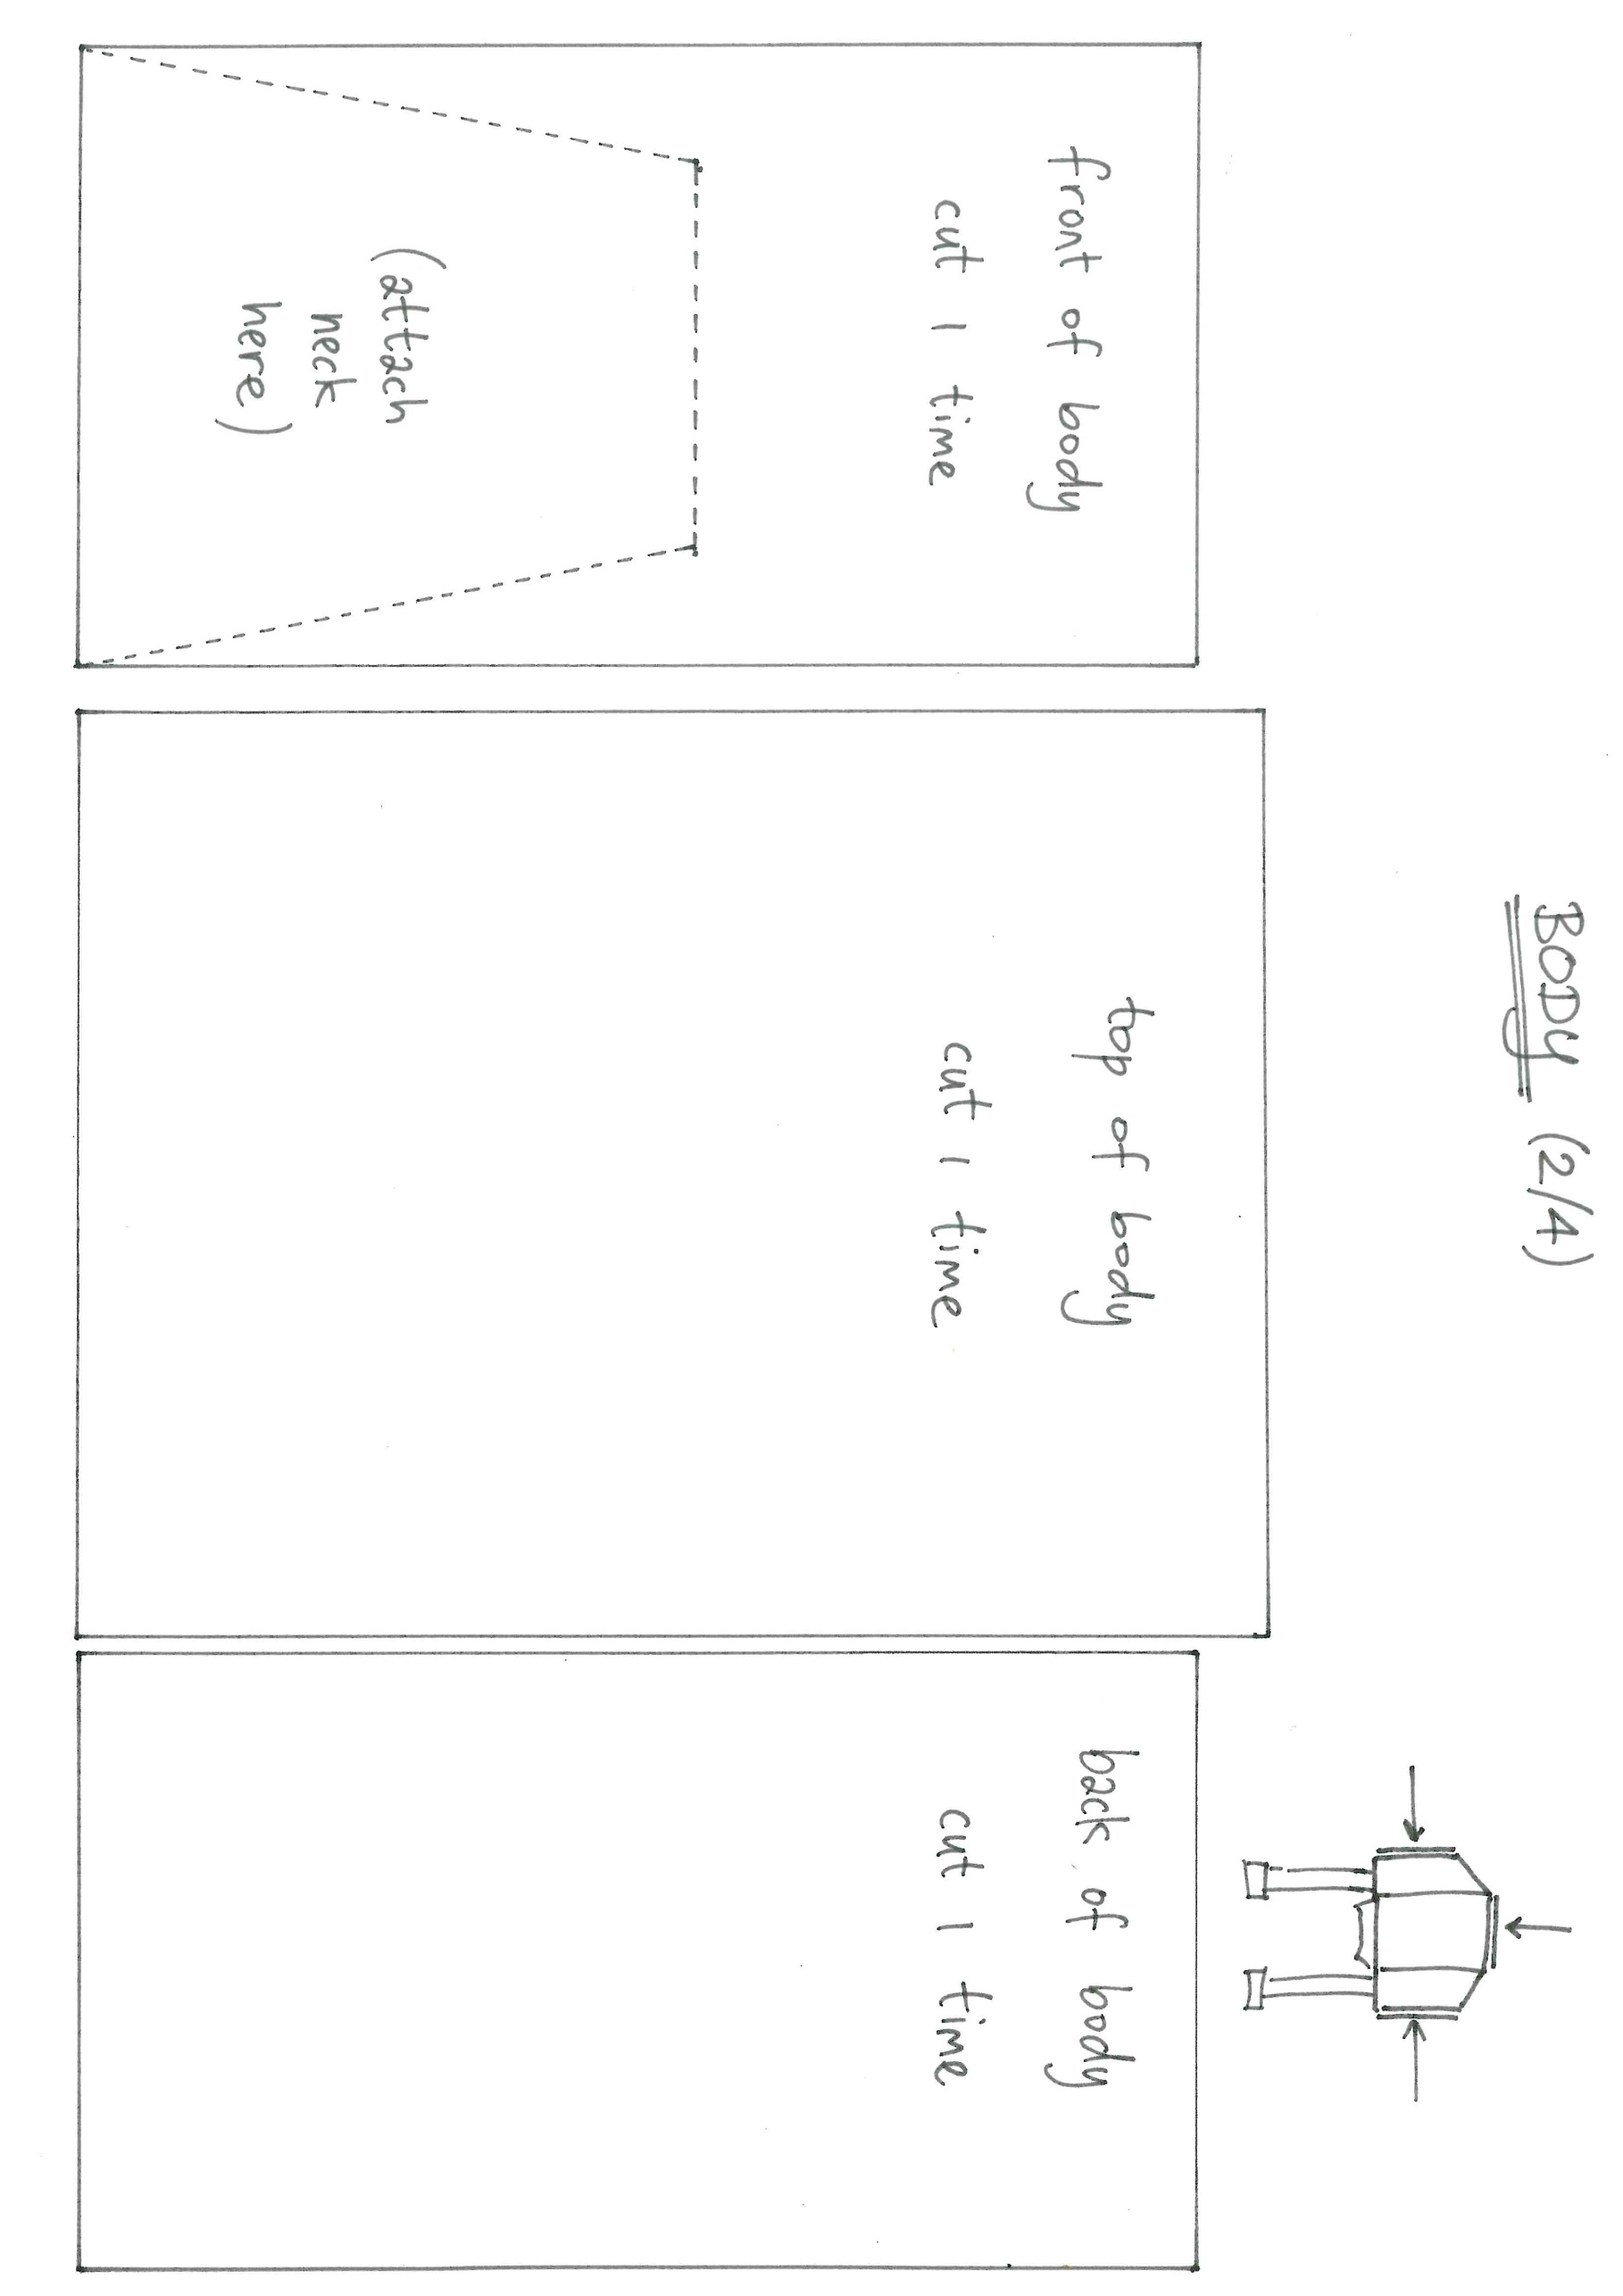
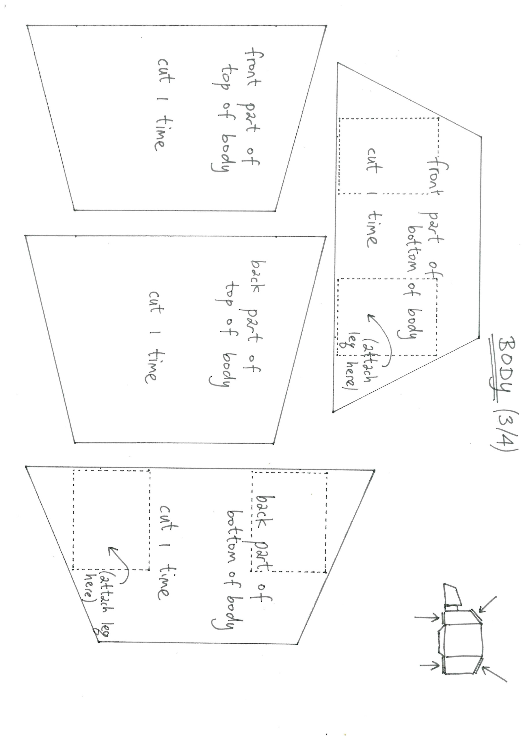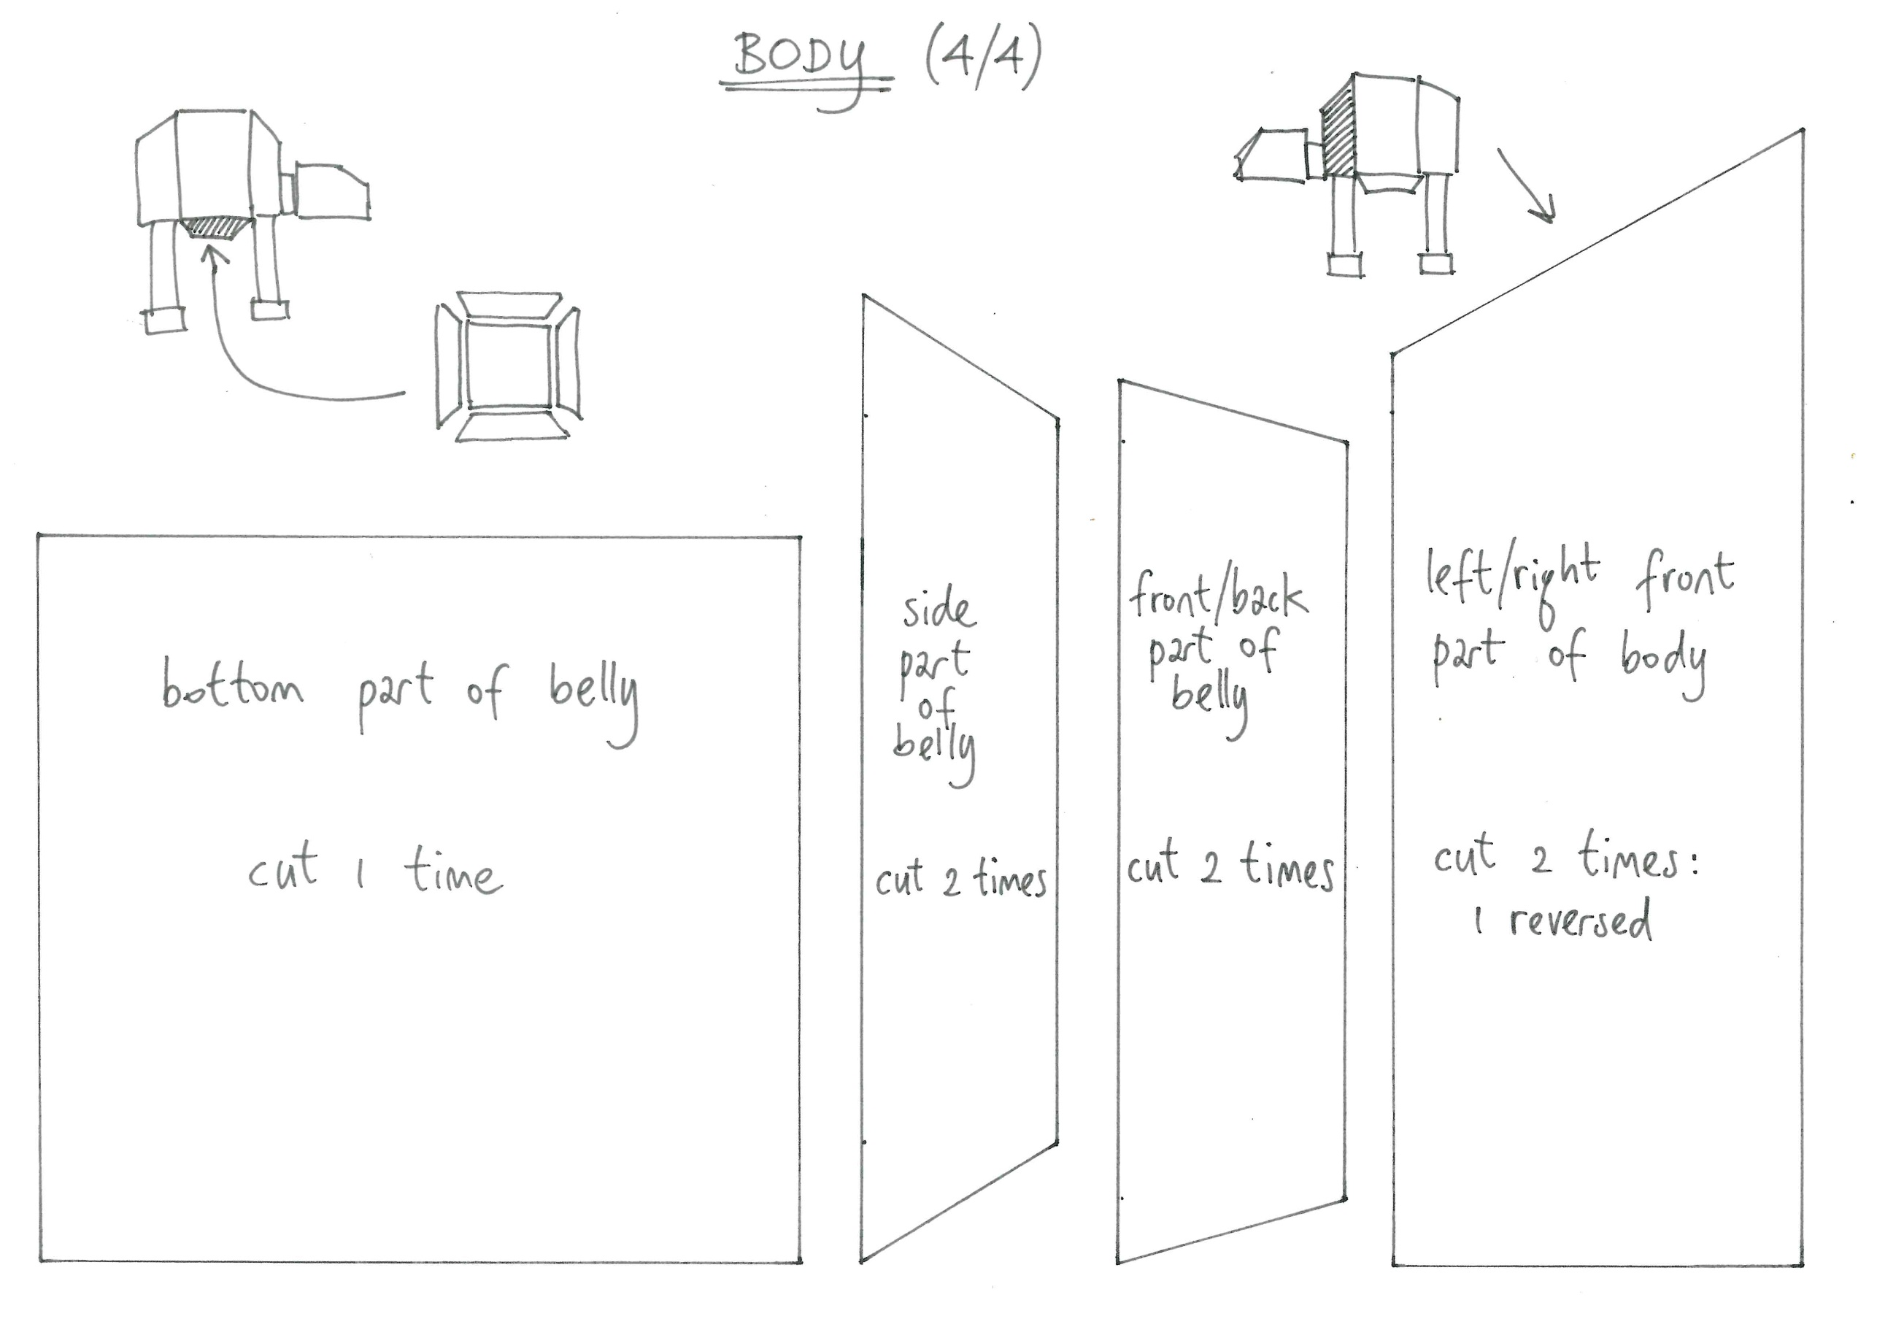
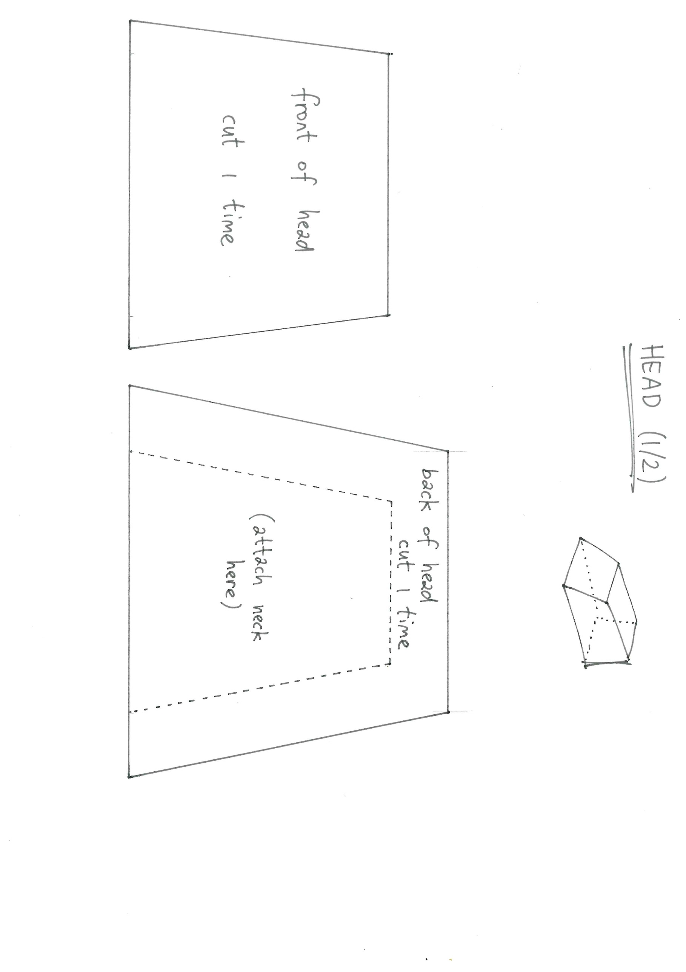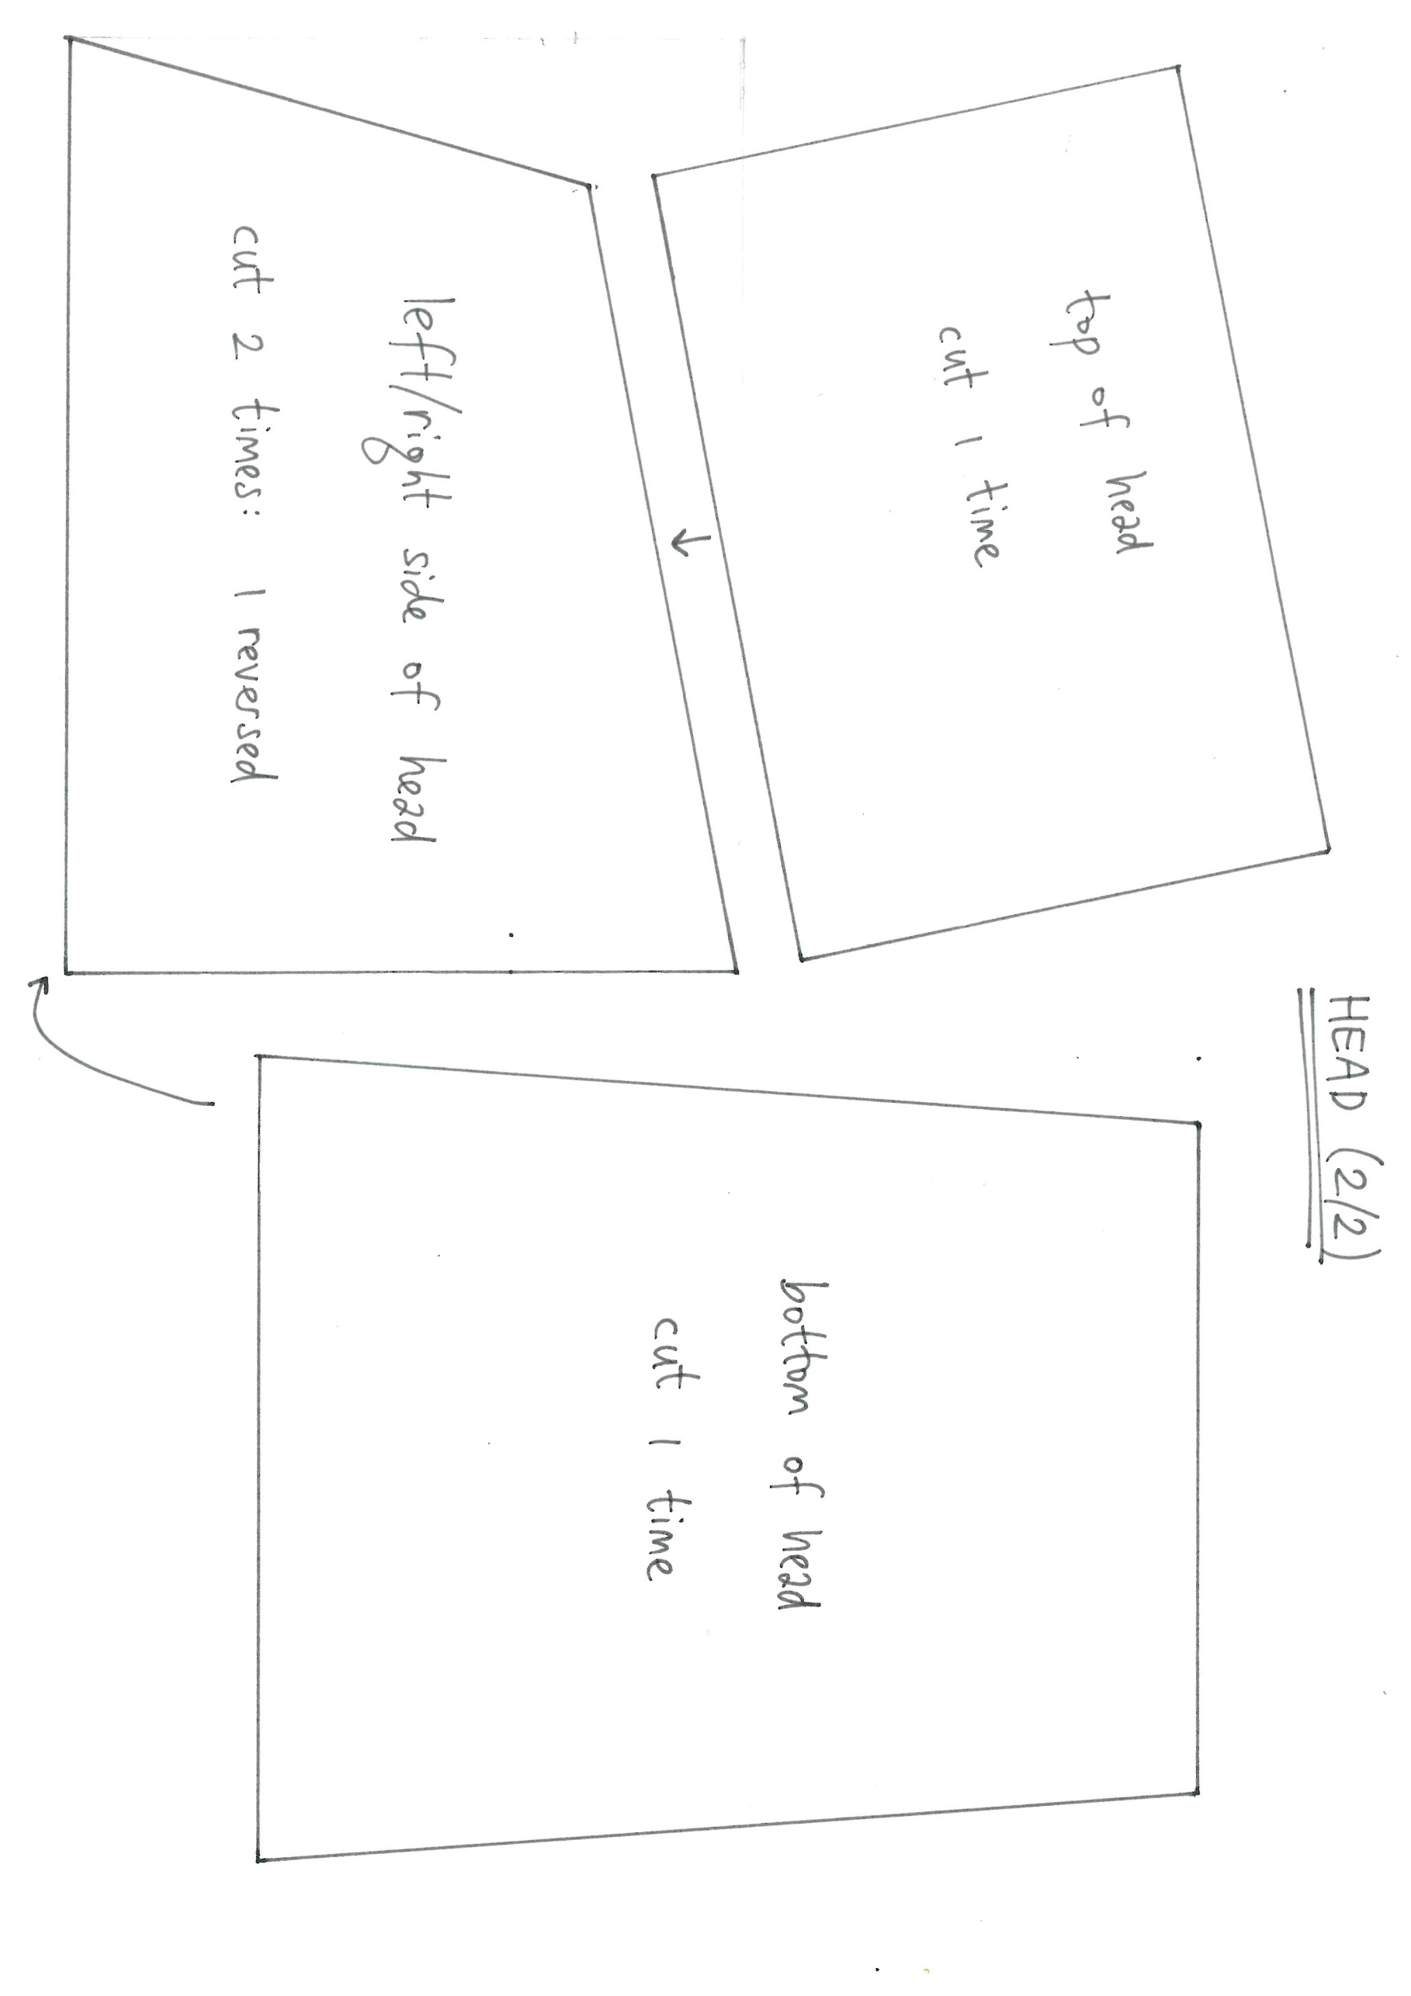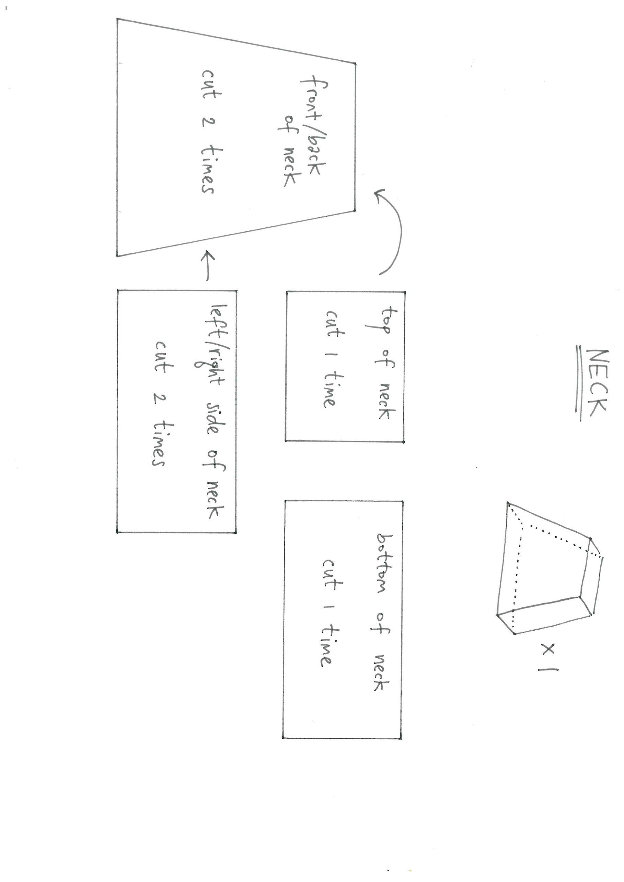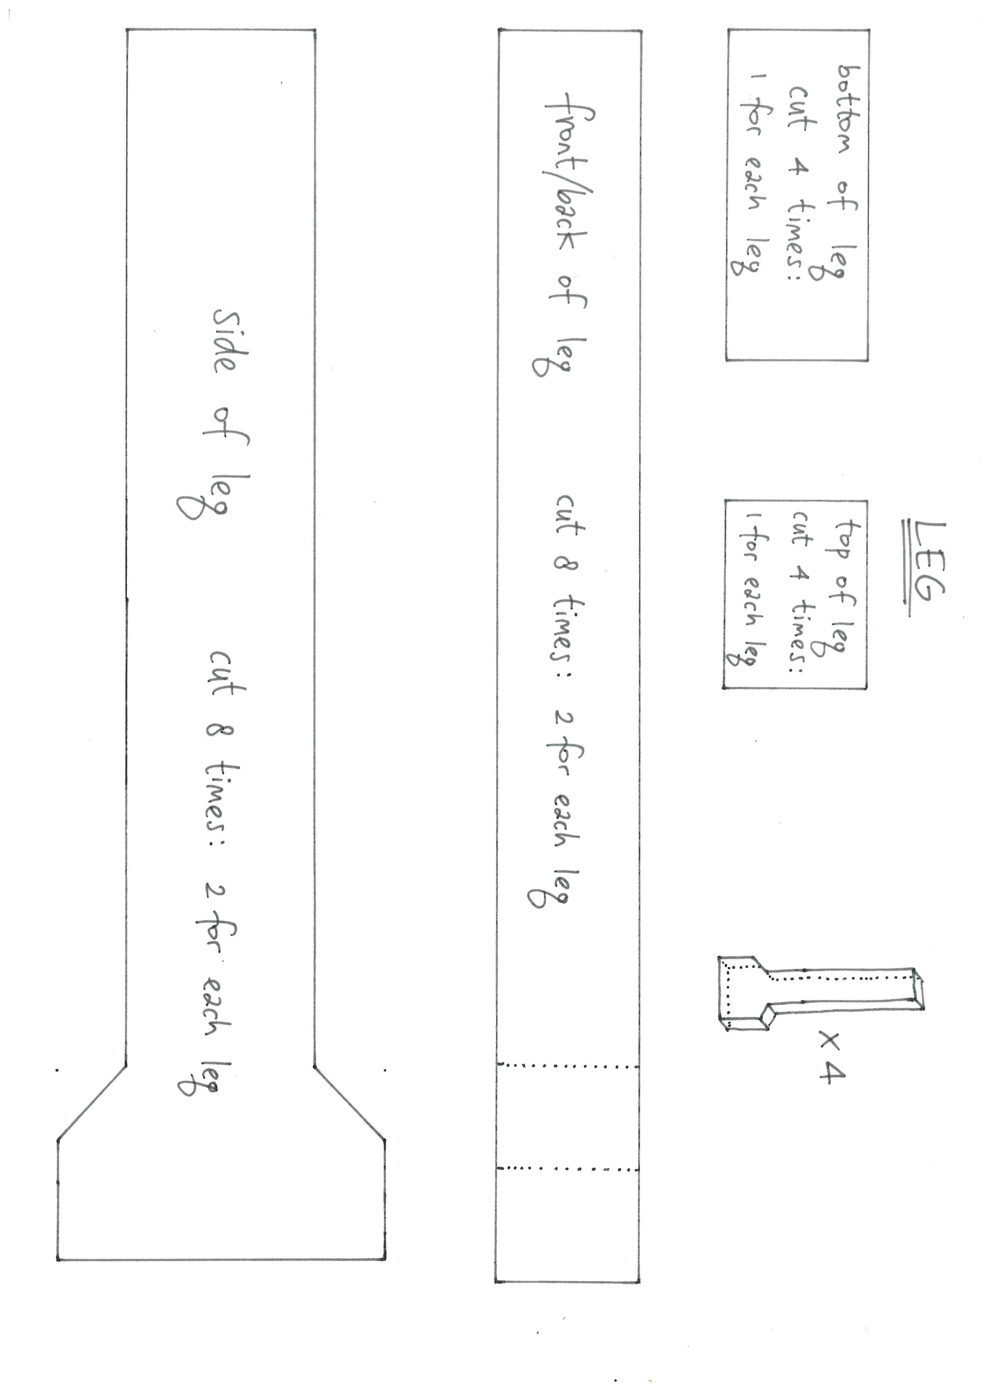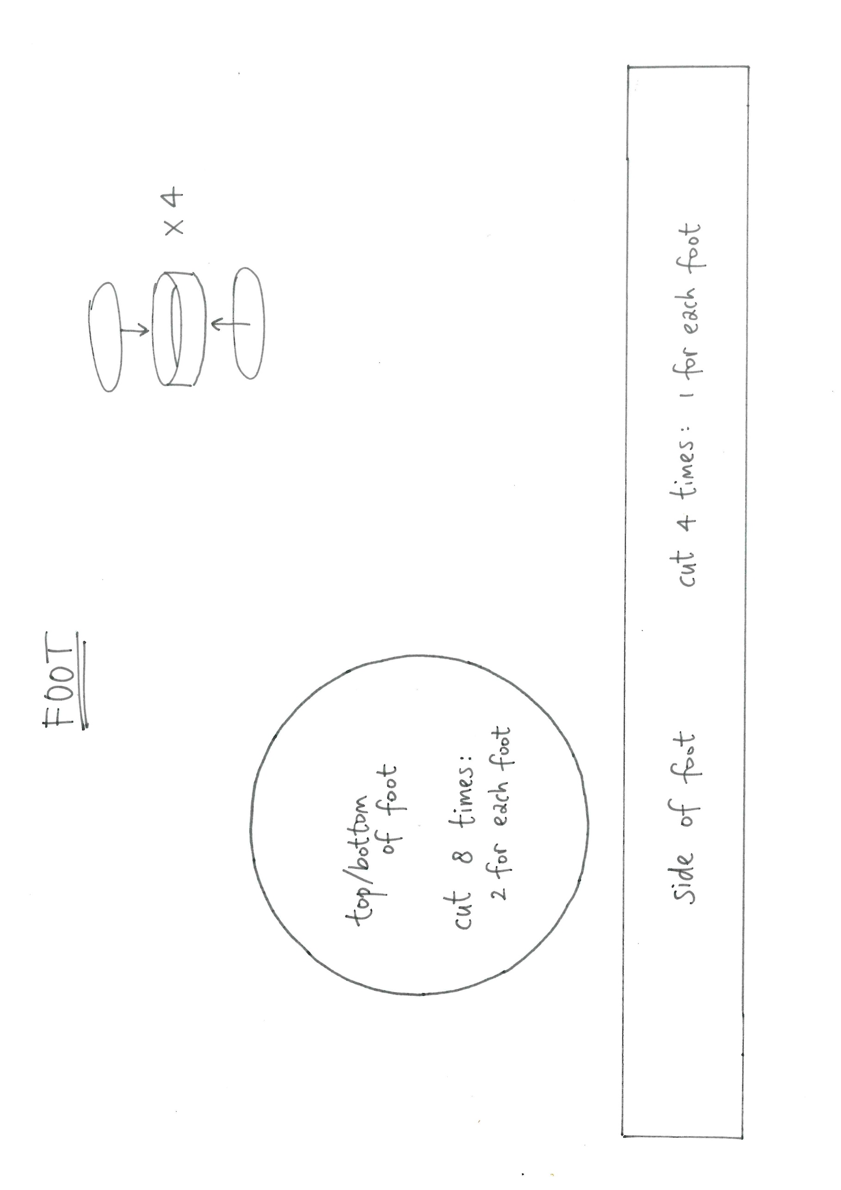
Below is an order of work that may be useful,
but of course you can decide for yourself:

- Make the head, fill the head, close it
- Make the neck, attach the neck to the head, fill the neck, close it
- Make the body, attach it to the neck, fill the body, close it
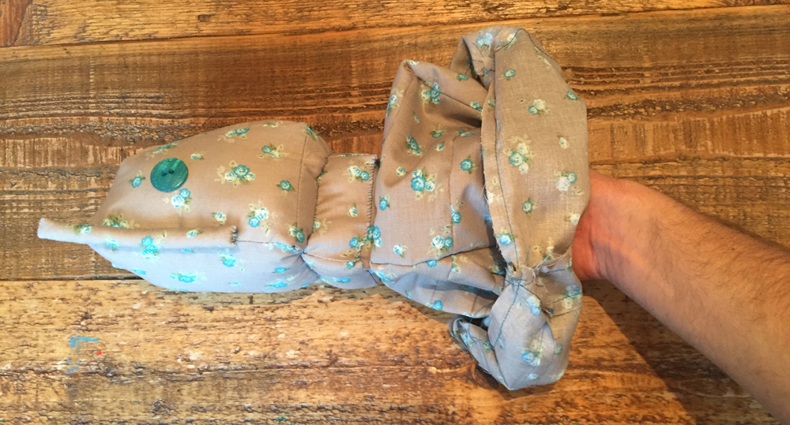
- Make the legs and the feet and attach the feet to the legs
- Attach the legs to the body

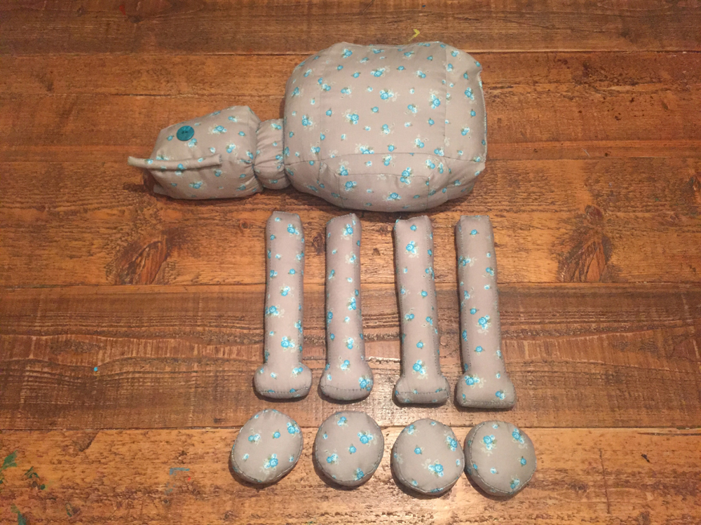

Here are some more photo’s that might be helpful,
because they give insight in how the AT-AT Walker is shaped: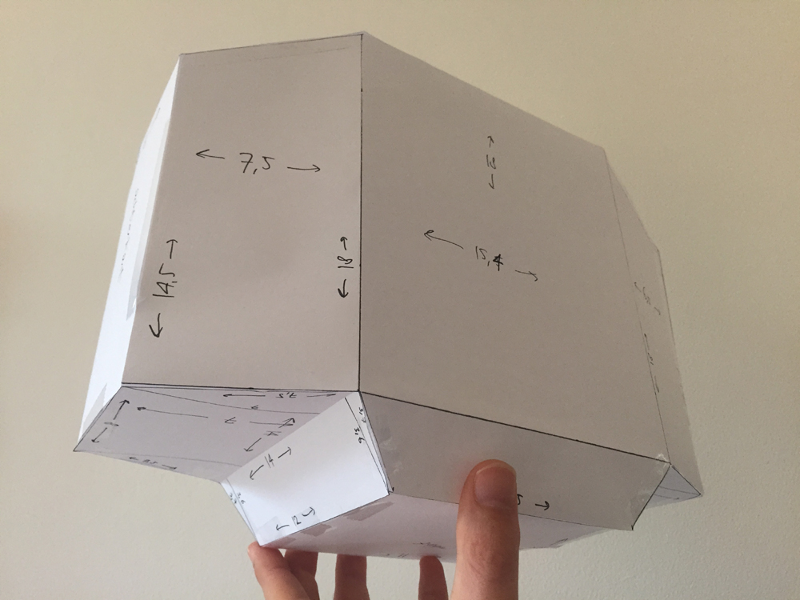

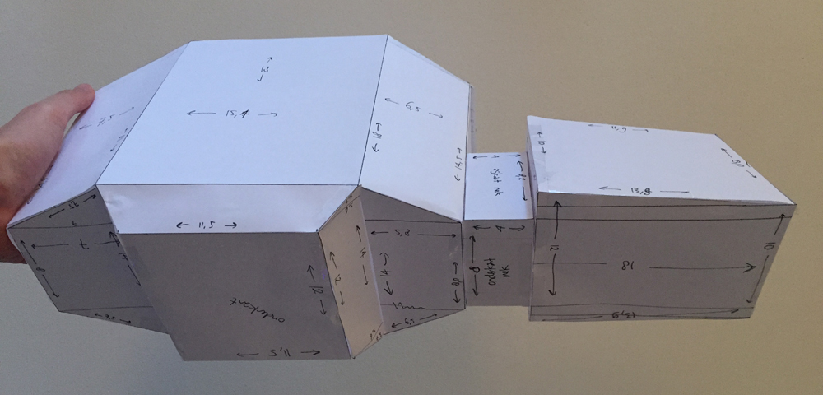

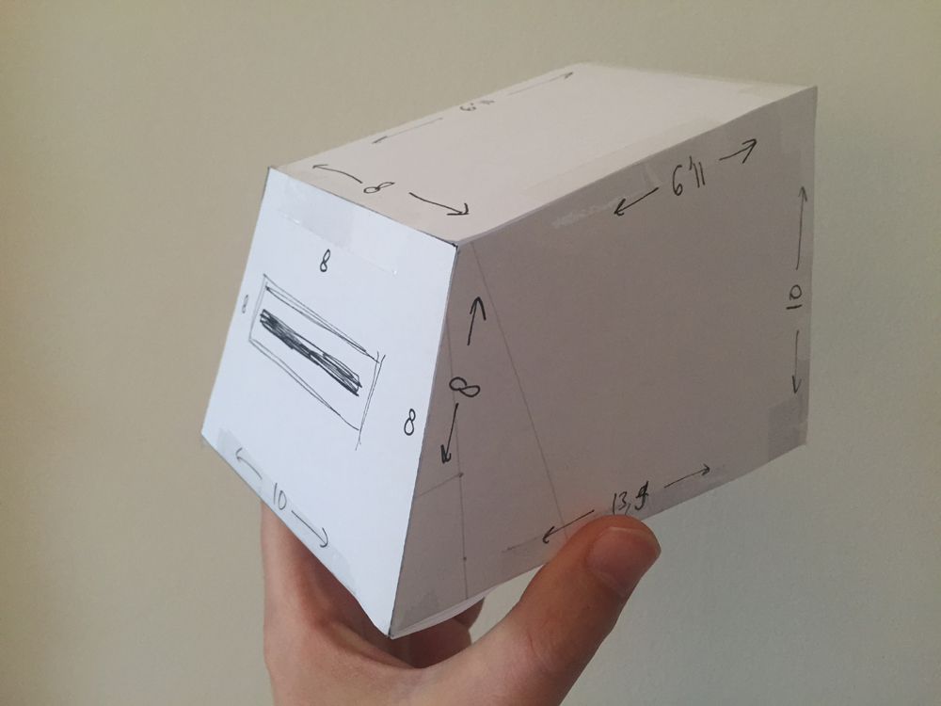

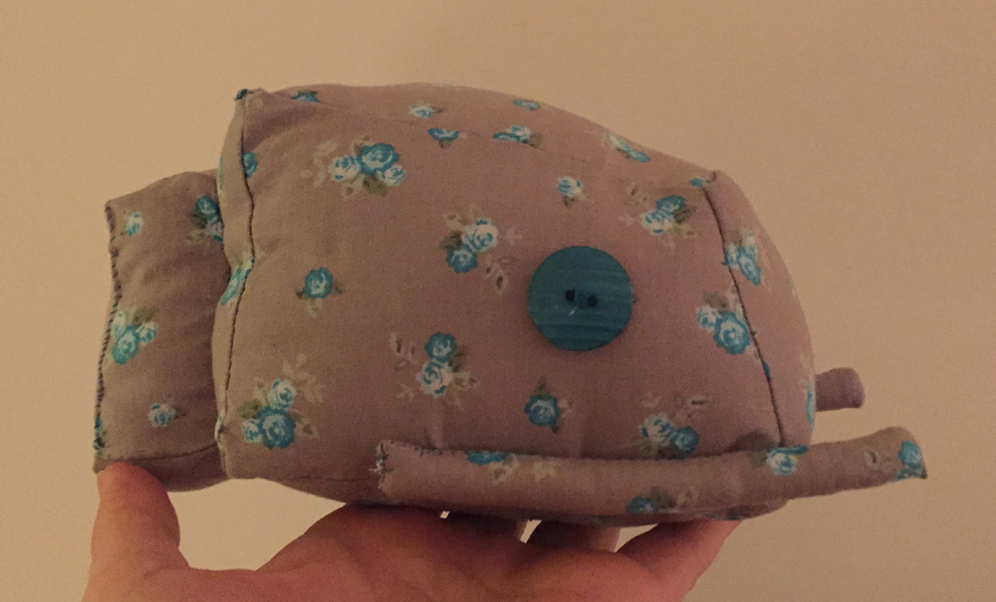

Please note:

- I filled it with plush, but you can also choose to fill it with foam block,
so the particular shapes will be even better noticable.

- The belly is pretty complicated.
Therefor you can also chose to make a ‘flat’ belly.
On the next page is the pattern for the alternative belly,
that you can just attach at the bottom of the body.

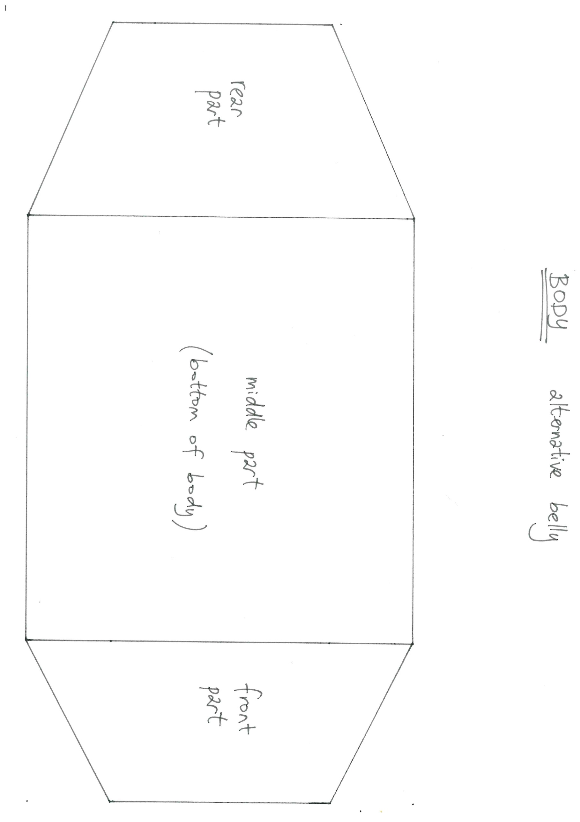

Good luck and have fun!

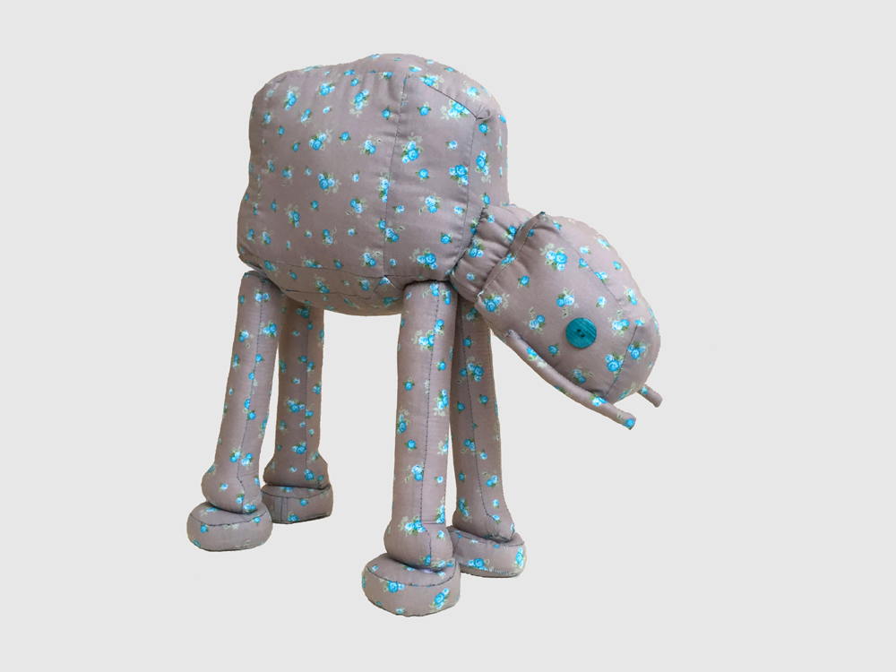

All text and images: © Sewbacca etsy.nl/sewbacca

